POWER BI PROJECT DOCUMENTATION

PIZZA SALES
This project analyzes pizza sales data to understand overall business performance, customer ordering behavior, and product-level trends. Using SQL for data analysis and Power BI for visualization, the project provides actionable insights into revenue, order patterns, best-selling pizzas, and category-wise sales performance. The objective is to support data-driven decision-making for sales growth and inventory planning.

PROBLEM STATEMENT
A pizza restaurant wants to analyze its sales data to gain insights into revenue generation, customer ordering trends, and product performance. The management aims to identify peak sales periods, popular pizza categories and sizes, and best- and worst-performing pizzas to optimize pricing, promotions, and inventory management.

Why this analysis is needed?
- To track total revenue and overall business performance
- To understand daily and monthly order trends
- To identify popular pizza categories and sizes
- To determine best-selling and low-performing pizzas
- To support strategic decisions related to promotions and menu optimization.
What decision it supports?
- Identifying top-performing pizzas to promote
- Understanding low-selling items for improvement or removal
- Optimizing inventory based on demand trends
- Planning marketing campaigns based on sales patterns
- Improving operational efficiency and profitability
Business Goal
- Increase total revenue
- Improve sales forecasting
- Optimize product offerings
- Enhance customer satisfaction through better menu planning

Analytical Goal
- Calculate key sales KPIs
- Analyze trends across time (daily and monthly)
- Measure category-wise and size-wise sales contribution
- Identify best and worst sellers based on revenue and quantity

Dataset Information
- Dataset Name: Pizza Sales Dataset
- Source: Internal / Kaggle-based dataset
- Type: Transactional sales data
- Table Name: pizza_sales
Key Columns:
- order_id
- order_date
- pizza_name
- pizza_category
- pizza_size
- quantity
- total_price

Data Quality & Assumptions
Data Quality Checks:
- Verified duplicate order IDs
- Checked for null values in key columns
- Ensured numeric fields (quantity, total_price) were valid
Assumptions:
- Each order_id represents a unique customer order
- total_price accurately reflects final sales value
- All dates are correctly recorded

Data Cleaning Steps
- Removed duplicate records
- Ensured correct data types for date and numeric columns
- Checked for missing or invalid values
- Validated consistency across pizza categories and sizes

EDA(exploratory Data Analysis)
- Exploratory Data Analysis (EDA) was conducted to understand sales patterns, customer ordering behavior, and product performance. Revenue distribution was analyzed across pizza categories and sizes. Daily and monthly order trends were examined to identify peak demand periods. Product-level analysis helped identify best- and worst-performing pizzas. Order behavior metrics such as average order value and average pizzas per order provided insights into customer purchasing habits. Data quality checks confirmed the dataset was clean and suitable for analysis.

Feature Engineering
- Feature engineering was performed to derive meaningful business metrics from raw data. Key performance indicators such as total revenue, average order value, total orders, and average pizzas per order were calculated.
- Time-based features like day of the week and month were extracted from order dates to support trend analysis.
- Sales percentage metrics and ranking features were created to compare product performance across categories, sizes, and individual pizzas.

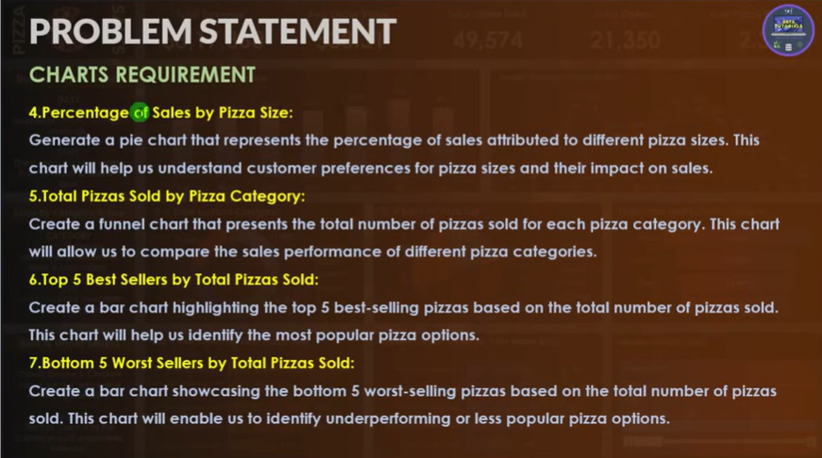

A. KPI’s
1. Total Revenue:
SELECT SUM(total_price) AS total_revenue FROM pizza_sales
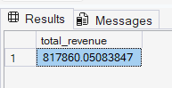

2.Average order value
SELECT
SUM(total_price)/COUNT(DISTINCT order_id) AS Avg_order_value
FROM pizza_sales
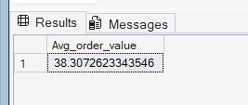

3.Total pizza sold
SELECT
SUM(quantity) AS total_pizza_sold
FROM pizza_sales
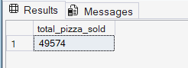

4.Total orders
SELECT COUNT(DISTINCT order_id) AS total_order FROM pizza_sales
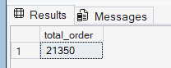

5.Average pizza per order
SELECT
CAST(CAST(SUM(quantity) AS DECIMAL(10,2)) /
CAST(COUNT (DISTINCT order_id) AS DECIMAL(10,2)) AS DECIMAL(10,2)) AS Avg_pizza_per_order
FROM pizza_sales
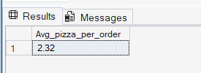

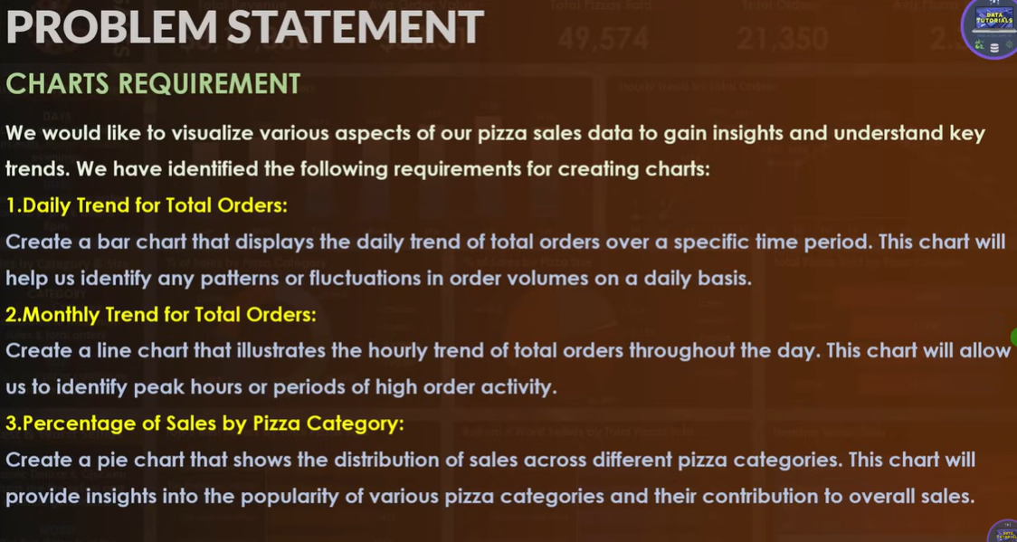
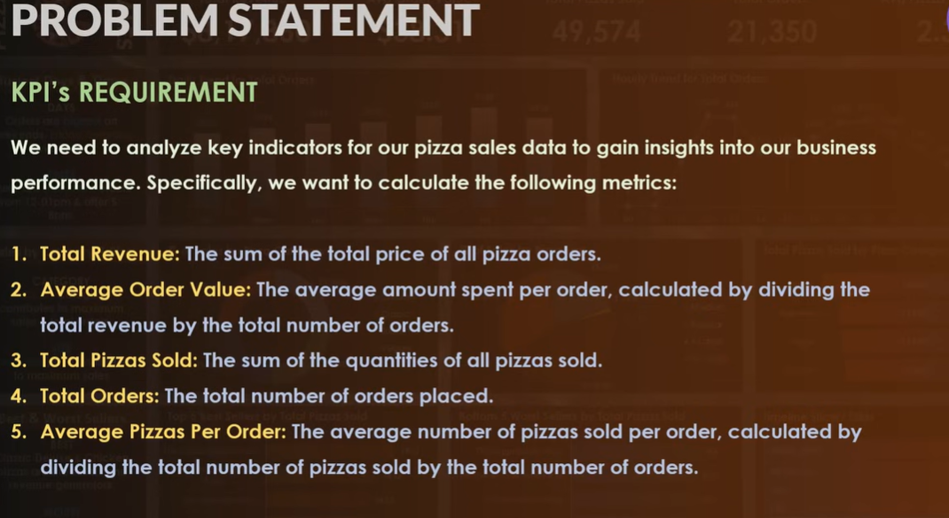
B.CHARTS REQUIREMENT
1.Daily trend for total orders
SELECT DATENAME(DW,order_date) AS order_day,
COUNT(DISTINCT order_id) AS total_order
FROM pizza_sales
GROUP BY DATENAME(DW,order_date)
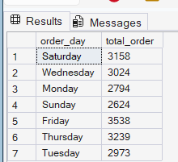

2. Monthly trend for total orders
SELECT DATENAME(MONTH, order_date) AS monthly_order,
COUNT(DISTINCT order_id) AS total_order
FROM pizza_sales GROUP BY DATENAME(MONTH, order_date) ORDER BY total_order
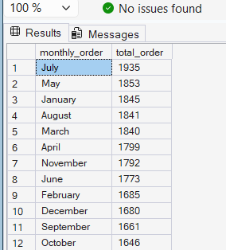

3.Percentage of sales by pizza category
SELECT pizza_category, SUM(total_price) AS Total_sales ,
SUM(total_price) * 100 / (SELECT SUM(total_price) pizza FROM pizza_sales) AS percentage_total_sales
FROM pizza_sales
GROUP BY pizza_category
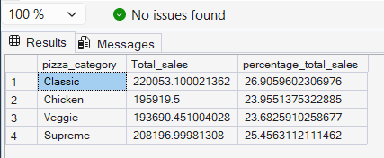
NOTE:
WE CAN FILTER THE SALES ACCORDING TO OUR REQUIRED MONTH
USED SUBQUERY HERE
SELECT pizza_category,SUM(total_price) AS Total_sales ,
SUM(total_price) * 100 /
(SELECT SUM(total_price) pizza FROM pizza_sales WHERE MONTH(order_date)=1) AS percentage_total_sales
FROM pizza_sales
WHERE MONTH(order_date)=1
GROUP BY pizza_category
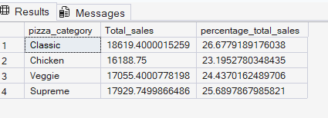

4. PERCENTAGE OF SALES BY PIZZA SIZE
SELECT pizza_size,SUM(total_price) AS Total_sales ,
CAST(SUM(total_price) * 100 /
(SELECT SUM(total_price) pizza FROM pizza_sales )AS DECIMAL(10,2)) AS percentage_total_sales
FROM pizza_sales
GROUP BY pizza_size
ORDER BY percentage_total_sales DESC
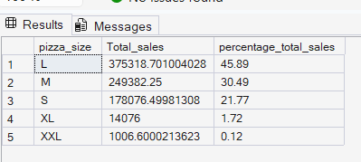

5. TOP 5 BESTSELLR BY TOTAL PIZZA SOLD
SELECT TOP 5 pizza_name, SUM(total_price) AS total_revenue
FROM pizza_sales
GROUP BY pizza_name
ORDER BY total_revenue DESC

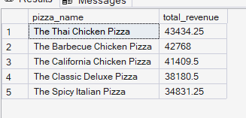

6. BOTTOM 5 WORSTSELLER BY TOTAL PIZZA SOLD
SELECT TOP 5 pizza_name, SUM(total_price) AS total_revenue
FROM pizza_sales
GROUP BY pizza_name
ORDER BY total_revenue ASC
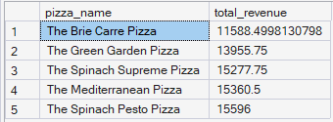

7.W.R.T quantity TOP 5
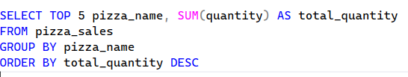
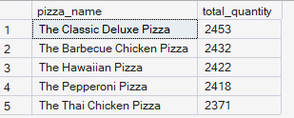

DATA CLEANING
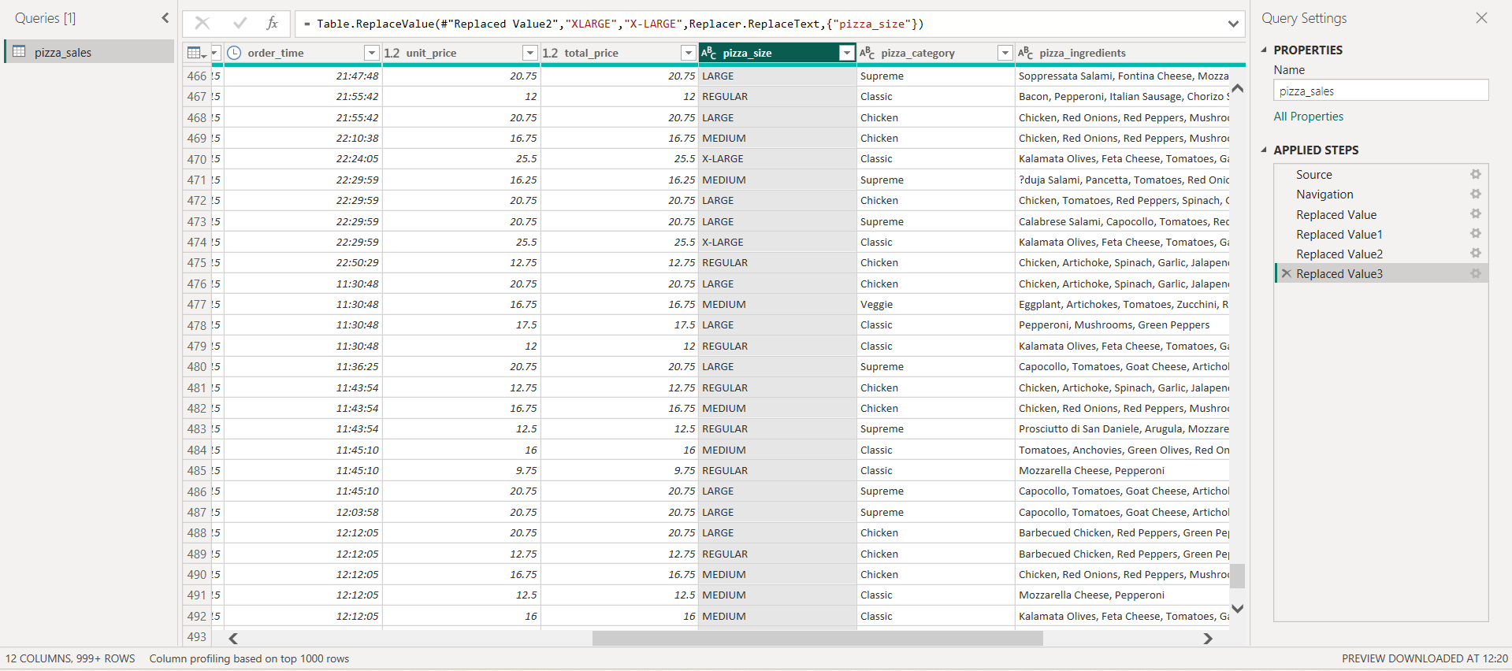

HOME DASHBOARD
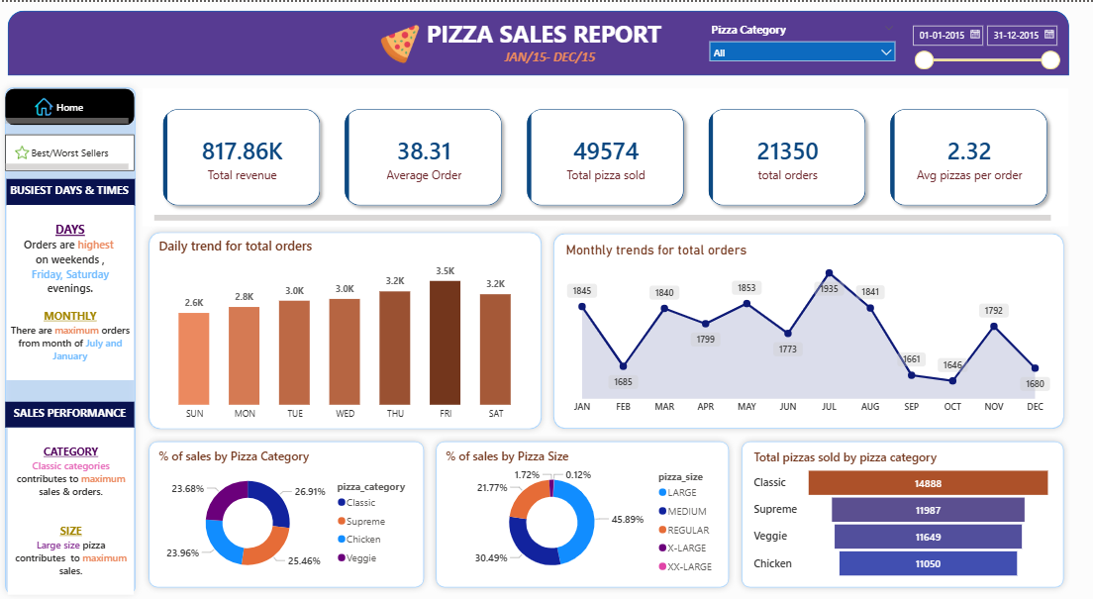

BEST & WORST SELLER DASHBOARD
